**YOURHELP- Your Hospital Finder**

**MAJOR PROJECT REPORT**

***Submitted in partial fulfilment of th*e *requirements for the award of the degree***

***of***

**BACHELOR OF TECHNOLOGY**

***in***

**COMPUTER SCIENCE & ENGINEERING**

***by***

**Shilpa Guleria Pranav Kapoor Varun Chauhan**

**Enrollment No:20115602715 Enrollment No:06615602715 Enrollment No:40515602715**

***Guided by***

**Mr. Pranav Shrivastava**

**Assistant Professor**

**Department of CSE**



**DEPARTMENT OF COMPUTER SCIENCE & ENGINEERING**

**DR AKHILESH DAS GUPTA INSTITUTE OF TECHNOLOGY AND MANAGEMENT**

**(AFFILIATED TO GURU GOBIND SINGH INDRAPRASTHA UNIVERSITY, DELHI)**

**NEW DELHI – 110053**

**JUNE 2019**

**CANDIDATE’S DECLARATION**

It is hereby certified that the work which is being presented in the B. Tech MAJOR Project Report entitled **“YOURHELP-Your Hospital Finder”** in partial fulfilment of the requirements for the award of the degree of **Bachelor of Technology** and submitted in the **Department of Computer Science & Engineering** of **Dr. Akhilesh Das Gupta Institute of Technology & Management, New Delhi (Affiliated to Guru Gobind Singh Indraprastha University, Delhi)** is an authentic record of our own work carried out during a period from **January 2019 to June 2019** under the guidance of **Mr. Pranav Shrivastava, Assistant Professor, Deptt. of CSE.**

The matter presented in the B. Tech MINOR Project Report has not been submitted by me for the award of any other degree of this or any other Institute.

**Shilpa Guleria Pranav Kapoor Varun Chauhan**

**(En. No: 20115602715) (En. No: 06615602715) (En. No: 40515602715)**

This is to certify that the above statement made by the candidate is correct to the best of my knowledge.They are permitted to appear in the External MAJOR Project Examination.

**Mr. Pranav Shrivastava Dr. Saurabh Gupta**

**Assistant Professor, Deptt. of CSE Head of Department, Deptt. of CSE**

The B. Tech Minor Project Viva-Voce Examination of **Shilpa Guleria (En. No: 20115602715), Pranav Kapoor (En. No: 20215602715) and Varun Chauhan (En. No: 20325602715)** has been held on **……………………………….**

**Dr. Anupam Kumar Sharma** **(Signature of External Examiner)**

**Project Coordinator, Deptt. of CSE**

**ABSTRACT**

During medical emergencies, patients are often shunted from hospital to hospital due to lack of ICU beds leading to loss of many lives. Also crucial time is lost calling up every individual blood bank trying to find blood of the required group in an emergency. In a crisis, as those precious seconds slip away, knowing where the nearest vacant ICU bed is or how many blood bottles of the required type the nearest blood banks have, can mean the difference between life and death. However, no service that provides such crucial real time information exists in most parts of the world - information that would be valuable during personal medical emergencies as well as natural disasters, terrorist attacks and public health epidemics.

In any case of emergency, the relatives or public take the patients to the nearest hospitals for treatments.There are chances that the further treatment and required services might not be available at that hospital. The hospital management may suggest taking the patient to some other hospital. Again moving the patient to other hospital for treatment is time consuming, expensive and it leads to discomfort of patient.

This situation occurs because the relatives or public are unaware of the services provided by the hospital. So we need a system which gives all information related to different hospitals in an efficient manner and that could be accessed easily during emergencies and could save a lot of time of the patient.. This is the application which provides the information related to different hospitals nearby to the user’s location. A user-friendly healthcare application is proposed which facilitates the patients a list of nearest hospitals and along with the feature of services availability. So this application provides the hospital details such as services types, specialization details etc.

**ACKNOWLEDGEMENT**

We express our deep gratitude to **Prof. (Dr.) Sanjay Kumar, Director** for providing us the facilities to carry out our project work. We would like to extend our sincere thanks to **Dr. Saurabh Gupta, Head of the Department, Deptt. of CSE** for his time to time suggestions to complete our project work.

We are thankful to **Dr. Anupam Kumar Sharma,** Project Coordinator, CSE Department for his valuable guidance. We would also like to thank all the faculty and staff members for their encouragement.

We are thankful to our guide,  **Mr. Pranav Shrivastava**, Assistant Professor, Department of Computer Science & Engineering for his valuable guidance and suggestion throughout our project work.

**Sign Sign Sign**

**Shilpa Guleria Pranav Kapoor Varun Chauhan**

**(En. No:20115602715) (En. No:06615602715) (En. No:40515602715)**

**TABLE OF CONTENTS**

|  |  |
| --- | --- |
| **Topic** | **Page No.** |
| DECLARATION | i |
| ABSTRACT | ii |
| ACKNOWLEDGEMENT | iii |
| TABLE OF CONTENTS | iv |
| LIST OF FIGURES | v |
| Chapter 1: Introduction   * 1. Objective   2. Features of the Application   3. Introduction to System | 1-4 |
| Chapter 2: Literature Survey | 5-8 |
| Chapter 3: System Analysis   * 1. Existing System   2. Proposed Method   3. Approach Adapted   4. Feasibility Study | 9-13 |
| Chapter 4: Requirement Analysis   * 1. Software Requirement Specification   2. Product Perspective   3. Functional Requirements | 14-25 |
| Chapter 5: Design of the project   * 1. Context Data Flow Diagram   2. Data Flow Diagrams   3. Use Case Diagrams   4. ER Diagram | 26-31 |
| Chapter 6: Methodology   * 1. Modules Description | 32-40 |
| Chapter 7: Results and Discussion | 41-42 |
| Chapter 8: Conclusion | 43 |
| Chapter 9: Future Scope | 44 |
| REFERENCES | vi |

**LIST OF FIGURES**

|  |  |
| --- | --- |
| **Figure No.** | **Label** |
| 3.1 | Waterfall Model |
| 4.1 | Front End |
| 4.2 | Backend |
| 5.1 | Context Free Diagram |
| 5.2 | DFD of Admin |
| 5.3 | DFD of User |
| 5.4 | Use Case Diagram |
| 5.5 | ER Diagram |
| 6.1 | Search Hospitals Module |
| 6.2 | Selecting Age Group |
| 6.3 | Selecting Disease |
| 6.4 | Customising the Search |
| 6.5 | Database in Mongo DB |
| 7.1 | Hospital Information Module |

**CHAPTER 1: INTRODUCTION**

The latest Smart phones made dramatic breakthroughs in processing power, higher random access memory, and secondary storage along with the number of extra features like internet access have opened doors to a broad range of applications development. An Android operating system (AOS) commonly used by Smartphone manufactures  because it is an open source operating system based on the Linux kernel and designed primarily for touch screen mobile devices such as Smart phones and tablet computers. The internal hardware of Smart phones especially sensors like proximity, accelerometer and gyroscope sensors are used by some applications to respond to additional user actions. There are different applications (apps) categories available for download from the online Google play store. Everyday thousands of new apps are uploaded in their online database. A number of applications related to healthcare are available in the medical category which is helpful in the diagnosis of vital sign parameters, vaccinations schedule, medicine reminder etc. These kinds of applications are lies in mobile-health (m-health) technology. Some applications determine the location of health clinics, healthcare centers and city hospitals. [1] Authentic and up-to-date information are available about each hospital and doctor. The following information helps in analyzing and choosing the AOS platform for this hospital finder App.

A detailed description of Android application framework from the prospective of developers is introduced in the Android platform and application. A simple music player is provided as instance to illustrate the basic working processes of Android application components. Guidance to understanding the operation mechanism of Android applications and to developing applications on Android platform is provided. [5] An innovative research approach to design and develop mobile consumer applications across communication network is presented in which the design involves mobile client that receives services provided by the  base station server connected to database server. Target consumer applications implemented were Electronic Health Record (EHR) and Utility billing application which tested for correctness and analyzed for performance with varying input data type and size.

Google maps is there for any particular location, any particular landmark etc. but there is an application for Android phones which helps people find only the hospitals, clinics and health service places at and around any particular location, which is indeed a helpful thing when someone needs to find a health care center around the place they are, in emergency but can’t find anything through Google maps because of the limited knowledge of the usage where one could not sort the results in particular.

One of the best advantages of this Hospital Finder application is that you even get to know all the locations of the dental hospitals, apart from the medical health care centers, and you get the options to call the phone number given in the listing. i.e. you don’t need to type in the phone number by noting it down, but you can just click on the phone number and it would initiate the call.

The application is linked to the Google maps from within its interface, and when you wanted to find the particular hospital and its location on the map, it would take you to the highest zoom and most of the other landmarks around it are given, making it easier for you to find the exact location while you are traveling.

In case one has an option to call in case of emergency, the services like Justdial would be helpful but for those with an internet as option to search, the Hospital Finder application is a lot helpful where you don’t have to search for the location and hospitals around, where you get the other listings such as restaurants, pubs, coffee lounges, banks, stations etc. along with the hospitals and health care centers which you are searching for.[2]

If you are not familiar with the places which you are searching for, the option of searching based on the radius around a place comes out handy. One can search for hospital within the area of maximum 20 km from the place where you are searching. Increasing the radius area would help in getting more results, and also you could find the places which you are familiar with, making things easier when you are in an emergency.There aren’t always the same times when you would not be able to make a call for emergency, and would need to rely on the applications or the internet. The Hospital Finder app could be the best help in such cases.

**1.1 OBJECTIVE**

* The main aim of this project is to provide service to patient in terms of saving their time and find the nearest hospital.

The nearest position of hospitals is calculated with a built-in feature of Global Positioning System in Smart Phones and finds the route from their current location through Google Map application Program Interfaces (API). An informative survey of different hospitals is conducted to obtain an accurate list of doctors available in each hospital.

* With the help of this application, a patient can find the nearest hospital according to specialized consultant availability. A comprehensive profile of doctor and hospital is available in the application including the website, mailing addresses and contact numbers.

**1.2 FEATURES OF THE APPLICATION**

* Enter your location, or it searches based on GPS – and it finds the hospitals around your location
* Separate listing for each hospital, having options of calling the number, checking the details of the hospital
* Opening the location of the hospital in Google maps, where people could search for the directions
* Adding any hospital to the “My favorite” section, from where you could access it anytime without having to search for it again.

**1.3 INTRODUCTION TO SYSTEM**

Some patients go to a hospital just for diagnosis, treatment, or therapy and then leave ('outpatients') without staying overnight; while others are 'admitted' and stay overnight or for several days or weeks or months ('inpatients'). Hospitals usually are distinguished from other types of medical facilities by their ability to admit and care for inpatients whilst the others often are described as clinics. The medical facility that is smaller than a hospital is generally called a clinic. Hospitals have a range of departments (e.g.: surgery, urgent care and intensive care) and specialist units such as cardiology. Some hospitals have outpatient departments and some have chronic treatment units. Common support units include a pharmacy, pathology, and radiology. A patient admitted to a hospital on medical emergency should be provided with required treatment.[3] If services are not available, patient has to be shifted to other hospitals which give them required service. But this can be time consuming where each second can save a life. It is expensive and cause discomfort to patient and their family. If the services provided by each hospital are known, the patients can be admitted to the hospital with required service.

There are already many existing applications in the field of hospitals, doctors and medicine. The available features include doctor recommendation, keeping track of the medications, information about the procedures, hospital directions and reviews of hospital.

The main aim of this application is to have added features which will enable a better experience for the user. An extremely simple user interphase with just the right amount of information is displayed. Nearest hospitals within a certain radius is displayed with the rating, phone numbers and route of the hospitals. Predicting the department, disease and service with the help of symptoms is a feature in the application. Blood banks and emergency hospitals are also available. The hospitals are displayed in terms of the required services and department to make the search easy for the users.

**CHAPTER 2: LITERATURE SURVEY**

**2.1 SURVEY FINDINGS**

**2.1.1 Domain specific search of nearest hospital and Healthcare Management System**

By R.A.Nimbalkar, R. A. Fadnavis, Dept. of Inf. Technol., Yeshwantrao Chavan Coll. of Eng., Nagpur, India.

Developed and developing countries have recognized the importance of Electronic Health Record in Healthcare Management System. Emergency Medical System (EMS) is a revolutionary approach to emergency medical treatment in some medical emergency. It also describes a mobile system that enables electronic healthcare data storage, update and retrieval using Cloud Computing. It observed that people in unknown area are in severe danger if they don't able to find hospital quickly. In emergency case a single minute counts so it is very important that automatic applications must be used for decision making, maintain up to date status of the hospital. Save the time which can be save life of the patient. When the doctor or family receives the alarm message, they can immediately take measures to rescue the user. It can also manage the health record of the user. The user can take online medical to send their physical condition and then get prescription from doctor who will send the prescription on the user's phone. The proposed system locates nearest available hospital, contacts its ambulance emergency system, and accesses an Electronic Health Record of emergency patient that can critically assist in pre-hospital treatments. The system will identify availability of the nearest available specialized hospital all through EMS server which provides continuous information about the incoming patient to the hospital. This paper proposes Android Based Tracking for EMS (Emergency Medical System) on cloud.

**2.1.2 Research on Emergency Call and Location Tracking System with Enhanced Functionality for Android**

By Dinesh B. Raut, Pragati Patil, Computer Science & Engineering Department Abha Gaikwad-Patil College of Engineering, Nagpur – India

Android is an operating system for mobiles which is based on the Linux kernel and currently developed by Google. Android is full featured and lightweight. Most of the Android applications are written in Java-like language that can be ported to new platform easily thereby adopting huge number of useful mobile applications. This paper elaborates the enhanced functionality of the emergency call for android. This is an application that people activate on mobile phones before you might get into an emergency situation. Then the people have to only press this application present on the home screen. Soon the device will send an emergency call or message to a friends, family, police, and doctors and send the exact current position. This system will help to people who fall into a situation where instant communication of their situations becomes indispensable to be informed to certain authorized persons.

Now a day’s security of women at the night and at a time even in a day when travelling alone anywhere is a big concern. Various terrible crimes have been occurring in the different parts of the country. New Delhi, the capital of India is a big eyewitness of such a crime. Along that when any person travel longer distance from the home in unknown areas, their security is an important concern also. It has been observed that the instance communication of message of one’s locations precisely is a problem. This paper describes Emergency Call system developed in Android platform. The individuality of this application separately from other application available is that the user needs not waste time navigating inside the phone menu i.e. to unlock the screen, to initiate the service. Instead of this they can directly press or touch the button and thus sending the location of that user in terms of latitude and longitude also name of that area along with the link of map which will show the location with the help of GPS. The location will be send to the pre-registered phone numbers in the application.

There are many such applications available in the market which sends a custom message to the number registered but not the location of that person also these applications are not able to send message again and again after some interval of time. But in this newly proposed and verified application the longitude and latitude information which gives the universal idea of the place of the current position of the mobile user is attached with the custom message that had been originally set in the application. And then this information is conveyed to the phone numbers which is registered already. So thus this newly featured application supports to find the exact location of the person in need also it will be so beneficial in tracing the location of occurrence easily at latter time.

**2.1.3 PATIENT MANAGEMENT:**

Healthcare has become one of world’s largest sectors - both in terms of revenue and employment. The industry comprises hospitals, medical devices, clinical trials, outsourcing, telemedicine, medical tourism, health insurance and medical equipment. The healthcare industry is growing at a tremendous pace due to its strengthening coverage, services and increasing expenditure by public as well private players.

The healthcare delivery system is categorized into two major components - public and private. The Government i.e. public healthcare system comprises limited secondary and tertiary care institutions in key cities and focuses on providing basic healthcare facilities in the form of primary healthcare centers (PHCs) in rural areas. The private sector provides majority of secondary, tertiary and quaternary care institutions with a major concentration in metros, tier I and tier II cities.

The primary competitive advantage over its peers lies in its large pool of well-trained medical professionals. Also, the cost advantage compared to peers in Asia and Western countries is significant - cost of surgery in a developing country is one-tenth of that in the US or Western Europe.

Developing countries have a life expectancy of 64/67 years (m/f), and an infant mortality rate of 46 per 1000 live births. In a lifetime, it is common that any human may fall ill, get wounds, or suffer from disease. The first step they do is consult a doctor or visit a hospital. The doctors gather information about the symptoms, wounds, body temperature etc and then analyses. Doctor may ask to get any test done and get the reports. By seeing the reports he starts medication. In a week or two, if patient suffers from anything, he might go to the same doctor or other. If he visits any other doctor, he would suggest any test. The same procedure might be followed. [9] Instead, if patient carries previous test reports, doctor can easily get more information and can treat him in a better way. If every patient’s data is available for a doctor then it is easy to analyze previous medical history and treat in a better way. Thus, saving each patient data in an integrated server becomes useful.

**CHAPTER 3: SYSTEM ANALYSIS**

**3.1 EXISTING SYSTEM**

On any medical emergency, the nearby family members or the public will take the patient to the surrounding hospital for the treatment. They will be unaware of the treatments and services available. If services are not available, the patient has to be shifted to other hospitals with more services and treatments. This can consume time, where even a second can play important role in saving a life. It will be quite expensive and leads to discomfort of the patient and their family. [6]

**3.1.1 Limitations of Existing system**

* Requires more time to track of any  particular record(Time Consuming)
* Lack of security& data accuracy
* Maximum Overhead when size of database grows
* Data redundancy exists
* Challenging task for maintaining the database
* Data retrieval becomes tedious job
* Overhead in maintaining different system format for all records.

**3.2 PROPOSED SYSTEM**

Instead of making the patients shift from hospital to hospital for required service and treatment, we give all necessary information about all the hospitals from the applications itself. There are two types of applications involved in this project. The administrator of the application adds all the details of cities, areas, hospitals, diseases, symptoms, department and different types of services available. The users or patients can get registered with the application to avail all the service. The users can view the hospitals and services provided, and also perform search based on city, hospitals and department names. This will refine their search in order to find the required treatment/services in any hospital.

The proposed application is a very diverse application which can easily be accessed by the registered members of the application. Users can access the nearest hospitals by using the GPS feature. Using the current location of the user the application fetches the nearest hospitals and provides the details about the hospital and their services. Based on the results obtained, patients can select hospital and get the route map for the selected hospital by users respectively. The proposed application has a unique feature of predicting the disease for the symptoms entered by the members and by this members can easily get to know the complete details about the diseases.

* 1. **APPROACH ADAPTED** 
     1. **Waterfall Model**

Waterfall model is the earliest SDLC approach that was used for software development.

Following is a diagrammatic representation of different phases of waterfall model that has been used in the development of the project.



*Figure 3.1: Waterfall Model*

In "The Waterfall" approach, the whole process of software development is divided into separate phases which involves its own sequence of steps that need to be executed for the development of the project.

The sequential phases in Waterfall model as used in the development of this project are:

• **Requirement Gathering and analysis:** All possible requirements of the system application for finding the nearby hospitals to be developed were captured in this phase. Here, the main requirements were that there was a need of a time efficient hospital searching application that could save a patient’s time in getting the medication.

• **System Design:** The requirement specifications from first phase were studied in this phase and system design was prepared. It mainly required the software for developing the front end (Ionic 4 and Angular 7) as well as the Back End( Node.js and MongoDB).

• **Implementation:** With inputs from system design, the system was first developed in small programs called units or modules. In this case, the different modules were that of age specific hospitals, disease specific hospitals etc.

• **Integration and Testing:** Finallyall the modules developed in the implementation phase were integrated into a single system of the Hospital Finder after testing of each unit.

• **Deployment of system:** Once the functional and non functional testing is done, the product is deployed in the customer environment or released into the market.

• **Maintenance:** There are some issues which come up in the client environment while the customer uses the application. Thus, all those issues and failures will be taken into account and changes would be done as per the need of the hour.

All these phases are cascaded to each other in which progress is seen as flowing steadily downwards (like a waterfall) through the phases.

**3.4 FEASIBILITY STUDY**

 The feasibility of the project is analysed in this phase and business proposal is put forth with a very general plan for the project and some cost estimates. During system analysis thefeasibility study of the proposed system is to be carried out. This is to ensure that the proposedsystem is not a burden to the company. For feasibility analysis, some understanding of the majorrequirements for the system is essential.Three key considerations involved in the feasibility analysis are:

3.4**.1 Economic Feasibility**

 This study is carried out to check the economic impact will have on the systemwill have on the organization. The amount of fund that the company can pour intothe research and development of the system is limited.The expenditures must be justified. Thus the developed system as well within the budget and this wasachieved because most of the technologies used are freely available. Only thecustomised products have to be purchased.

**3.4.2 Technical Feasibility**

 This study is carried out to check the technical feasibility, that is,the technicalrequirements of the system. Any system developed must not have a high demandon the available available technical resources. This will lead to high demands being placed on the client. The developed system must have a modestrequirement, as only minimal or null changes for the implementing this system.

**3.4.3 Operational Feasibility**

 The aspect of study is to check the level of acceptance of the system by theuser. This includes the process of training the user to use the systemefficiently. The user must not feel threatened by the system, instead mustaccept it as a necessity. The level of acceptance by the users solely dependson the methods that are employed to educate the user about the system and tomake him familiar with it. His level of confidence must be raised so that he isalso able to make some constructive criticism, which is welcomed, as he is thefinal user of the system.

**CHAPTER 4: REQUIREMENT ANALYSIS**

**4.1 SRS – SOFTWARE REQUIREMENT SPECIFICATION**

Software Requirement Specification is the starting point of the software development activity. It includes an introduction that gives the purpose, scope and an overview of the system. This needs requirement by talking to the people and understanding their needs. It also includes a general description of the product perspective, product function and certain user characteristics of the system. It also specifies the overall functional requirements, performance requirements and design constraints. The SRS is a means of translating the idea in the mind of the clients (the input), into a formal document (the output of the requirement phase). The Software Requirement Specification document is organized in such a manner it aids validation and system design.

**4.2 PRODUCT PERSPECTIVE**

**4.2.1 USER INTERFACE**

There are two types of actors. They are:

1. Administrator: Establishes Web system by planning and executing the selection, installation, configuration, and testing of server hardware, software, and operating and system management systems; defining system and operational policies and procedures.
2. Users: The visitor can view the basic information in homepage and view the opinions of the patients posted in the past about hospitals and services. The visitors can register to become member and post reviews and their expertise.

**4.2.2 SYSTEM REQUIREMENTS**

**Software interfaces:**

Operating System : Windows 7 or Higher

Coding Language : J2EE and Android

Back End : MYSQL

Java Software : JDK 1.7 or above

Android software : SDK

Tool : Eclipse, Android Studio

**FRONT END**

*Figure 4.1: Front End*

1. **Ionic v4**

Ionic is an HTML5 mobile app development framework targeted at building hybrid mobile apps. Hybrid apps are essentially small websites running in a browser shell in an app that have access to the native platform layer. Hybrid apps have many benefits over pure native apps, specifically in terms of platform support, speed of development, and access to 3rd party code.

Think of Ionic as the front-end UI framework that handles all of the look and feel and UI interactions your app needs in order to be compelling. Kind of like “Bootstrap for Native,” but with support for a broad range of common native mobile components, slick animations, and beautiful design.

Unlike a responsive framework, Ionic comes with very native-styled mobile UI elements and layouts that you’d get with a native SDK on iOS or Android but didn’t really exist before on the web. Ionic also gives you some opinionated but powerful ways to build mobile applications that eclipse existing HTML5 development frameworks.

## Supported platforms

Ionic is focused on building for modern Web standards and for modern mobile devices. For Android, Ionic supports Android 4.1 and up. For iOS, Ionic supports iOS 7 and up Ionic 2 supports the Universal Windows Platform for building Windows 10 apps. Ionic Framework, powered by *Angular.js*, supports BlackBerry 10 apps.

## Performance

Compared to hybrid applications, mixing Ionic code with native mobile app code in PhoneGap (now called Apache Cordova) allows for higher performance of the resulting product: utilizing AngularJS (rather than jQuery) allows Ionic to rely on native hardware acceleration (rather than extensive DOM manipulation). Ionic leverages CSS transitions and transforms for animation as a way to leverage the GPU and maximize available processor time.

## Services and features

Ionic uses Cordova plugins to gain access to host operating systems features such as Camera, GPS, Flashlight, etc.Users can build their apps, and they can then be customized for Android, iOS, Windows, or modern browsers. Ionic allows you to build and deploy your apps by wrapping around the build tool Cordova with a simplified 'ionic' command line tool.

Ionic includes mobile components, typography, interactive paradigms, and an extensible base theme.

Using Angular, Ionic provides custom components and methods for interacting with them. One such component, collection repeat, allows users to scroll through a list of thousands of items without any performance hits. Another component, scroll-view, creates a scrollable container with which users can interact using a native-influenced delegate system.

<**ion-content**>

</**ion-content**>

Developers can programmatically control the scroll-view to get the scroll position, scroll to bottom/top, zoom, or get information about the current scroll-view instances.

$ionicScrollDelegate.scrollTop();

$ionicScrollDelegate.scrollBottom();

$ionicScrollDelegate.zoomTo(1.5);

$ionicScrollDelegate.getScrollView();

Besides the SDK,  Ionic also provides services that developers can use to enable features, such as push notifications, A/B testing, analytics, code deploys, and automated builds.

Ionic also provides a powerful command-line interface (CLI), so developers can get started with creating a project with a simple command. The CLI also allows developers to add Cordova plugins and additional front-end packages, enable push notifications, generate app Icons and Splash screens, and build native binaries.

1. **Angular7**

Angular Material 7 is a UI component library for Angular developers. Angular Material components help in constructing attractive, consistent, and functional web pages and web applications while adhering to modern web design principles like browser portability, device independence, and graceful degradation. It helps in creating faster, beautiful, and responsive websites. It is inspired by the Google Material Design.

Following are a few salient features of Angular Material −

* In-built responsive designing.
* Standard CSS with minimal footprint.
* Includes new versions of common user interface controls such as buttons, check boxes, and text fields which are adapted to follow Material Design concepts.
* Includes enhanced and specialized features like cards, toolbar, speed dial, side nav, swipe, and so on.
* Cross-browser, and can be used to create reusable web components.

**Basic Building Blocks of Angular7**

The most basic building block of your Angular 7 application (and this is a concept that's not new) is the component. A component consists of three primary elements:

* The HTML template
* The logic
* The styling (CSS, Sass, Stylus, etc.)
* When we use the Angular CLI to start a new project, it generates a single component, which is found in **/src/app/**:
* /app.component.html
* /app.component.scss
* /app.component.ts
* While we have three files here that represent the three elements above, the **.ts** (TypeScript) is the heart of the component.

**BACK END**

*Figure 4.2: Back End*

### **Node.js**

### Node.js is an open-source, cross-platform JavaScript run-time environment that executes JavaScript code outside of a browser. JavaScript is used primarily for client-side scripting, in which scripts written in JavaScript are embedded in a webpage's HTML and run client-side by a JavaScript engine in the user's web browser. Node.js lets developers use JavaScript to write command line tools and for server-side scripting—running scripts server-side to produce dynamic web page content *before* the page is sent to the user's web browser. Consequently, Node.js represents a "JavaScript everywhere" paradigm, unifying web application development around a single programming language, rather than different languages for server side and client side scripts.

### Though .js is the standard filename extension for JavaScript code, the name "Node.js" does not refer to a particular file in this context and is merely the name of the product. Node.js has an event-driven architecture capable of asynchronous I/O. These design choices aim to optimize throughput and scalability in web applications with many input/output operations, as well as for real-time Web applications (e.g., real-time communication programs and browser games).

### **Basic Features of Node.js:**

### Node.js is an open source server environment

### It is free and uses JavaScript on the server

### It runs on various platforms (Windows, Linux, Unix, Mac OS X, etc.)

* Node.js runs single-threaded, non-blocking, asynchronously programming, which is very memory efficient.
* It can generate dynamic page content
* It can also create, open, read, write, delete, and close files on the server
* Further, it can collect form data and add, delete, modify it in your database.

### **Unified API**

Node.js can be combined with a browser, a database that supports JSON data (such as Postgres, MongoDB, or CouchDB) and JSON for a unified JavaScript development stack. With the adaptation of what were essentially server-side development patterns such as MVC, MVP, MVVM, etc., Node.js allows the reuse of the same model and service interface between client-side and server-side.

**Threading**

Node.js operates on a single thread event loop, using non-blocking I/O calls, allowing it to support tens of thousands of concurrent connections without incurring the cost of thread context switching. The design of sharing a single thread among all the requests that use the observer pattern is intended for building highly concurrent applications, where any function performing I/O must use a callback. To accommodate the single-threaded event loop, Node.js uses the libuv library—which, in turn, uses a fixed-sized thread pool that handles some of the non-blocking asynchronous I/O operations.

### **Event loop**

Node.js registers with the operating system so the OS notifies it of connections and issues a callback. Within the Node.js runtime, each connection is a small heap allocation. Traditionally, relatively heavyweight OS processes or threads handled each connection. Node.js uses an event loop for scalability, instead of processes or threads. In contrast to other event-driven servers, Node.js's event loop does not need to be called explicitly. Instead callbacks are defined, and the server automatically enters the event loop at the end of the callback definition. Node.js exits the event loop when there are no further callbacks to be performed.

### **Package management**

npm is the pre-installed package manager for the Node.js server platform. It installs Node.js programs from the npm registry, organizing the installation and management of third-party Node.js programs. Packages in the npm registry can range from simple helper libraries such as Lodash to task runners such as Grunt.

**Modules in Node.js**

Consider modules to be the same as JavaScript libraries.

## Built-in Modules

Node.js has a set of built-in modules which you can use without any further installation.

## Include Modules

To include a module, use the require() function with the name of the module:

var http = require('http');

You can create your own modules, and easily include them in your applications.

# MongoDB

**MongoDB** is a cross-platform document-oriented database program. Classified as a NoSQL database program, MongoDB uses JSON-like documents with schemata. MongoDB is developed by MongoDB Inc. and licensed under the Server Side Public License (SSPL).

Main features

* **Ad hoc queries**

MongoDB supports field, range query, and regular expression searches. Queries can return specific fields of documents and also include user-defined JavaScript functions. Queries can also be configured to return a random sample of results of a given size.

* **Indexing**

Fields in a MongoDB document can be indexed with primary and secondary indices.

* **Replication**

MongoDB provides high availability with replica sets. A replica set consists of two or more copies of the data. Each replica set member may act in the role of primary or secondary replica at any time. All writes and reads are done on the primary replica by default. Secondary replicas maintain a copy of the data of the primary using built-in replication.

* **Load balancing**

MongoDB scales horizontally using sharding. The user chooses a shard key, which determines how the data in a collection will be distributed. The data is split into ranges (based on the shard key) and distributed across multiple shards. (A shard is a master with one or more replicas.). Alternatively, the shard key can be hashed to map to a shard – enabling an even data distribution.

MongoDB can run over multiple servers, balancing the load or duplicating data to keep the system up and running in case of hardware failure.

* **File storage**

MongoDB can be used as a file system, called GridFS, with load balancing and data replication features over multiple machines for storing files.

This function, called grid file system, is included with MongoDB drivers. MongoDB exposes functions for file manipulation and content to developers. GridFS can be accessed using mongofiles utility.GridFS divides a file into parts, or chunks, and stores each of those chunks as a separate document.

* **Aggregation**

MongoDB provides three ways to perform aggregation: the aggregation pipeline, the map-reduce function, and single-purpose aggregation methods.Map-reduce can be used for batch processing of data and aggregation operations. But according to MongoDB's documentation, the Aggregation Pipeline provides better performance for most aggregation operations.

The aggregation framework enables users to obtain the kind of results for which the SQL GROUP BY clause is used. Aggregation operators can be strung together to form a pipeline – analogous to Unix pipes.

* **Server-side JavaScript execution**

JavaScript can be used in queries, aggregation functions (such as MapReduce), and sent directly to the database to be executed.

* **Capped collections**

MongoDB supports fixed-size collections called capped collections. This type of collection maintains insertion order and, once the specified size has been reached, behaves like a circular queue.

* **Transactions**

Support for multi-document ACID transactions was added to MongoDB with the General Availability of the 4.0 release in June 2018.

## Creating a Database in MongoDB

To create a database in MongoDB, start by creating a MongoClient object, then specify a connection URL with the correct ip address and the name of the database you want to create.

MongoDB will create the database if it does not exist, and make a connection to it.

MongoDB waits until you have created a collection (table), with at least one document (record) before it actually creates the database (and collection)

**4.3 FUNCTIONAL REQUIREMENTS**

**4.3.1 User Class-Admin:**

Admin has the following modules:

• *Login:* The Login Module is a portal module that allows users to type a user name and password to log in. One has to have the credentials to log in and manage the information.

• *Manage cities:* The manage cities module helps in keeping track of the cities in a particular area. The admins can edit the cities and also delete them.

• *Manage areas:* The manage area module helps the admin to keep track of the areas and the surrounding areas of the city. Each city has a list of areas to it.

• *Manage Hospital:* This module helps in maintaining the hospital lists in the desired area and city. The admin can edit by moving the hospital or deleting the hospital from a particular area with the help of Manage Hospital Module.

• *Manage Departments:* Each hospital has n number of departments with the hospital. This module helps the admin in maintaining and managing the departments of each hospital. It is the duty of the administrator to add or remove any department with respect to the changes within the hospital.

• *Manage service:* Services provided by each hospital differs. This module helps in managing the services in separate hospitals by adding or removing services in each department.

• *Manage Hospital service:* The manage hospital service is combination of two existing modules which makes it easier for the admin to manage the other existing department and keep track of the hospitals.

• *Manage symptoms:* This module helps in recording the existing symptoms and the most common symptoms that occur frequently in day to day life. When a new symptom is found it is up to the admin to add it to the list of existing symptoms. The user must select a minimum of three symptoms to get a valid result.

• *Manage diseases:* The admin revises the list of diseases and keeps it updated so that the users can figure out the near to accurate result. The disease deals with the symptoms and hence requires proper maintenance and this module helps in the process.

**4.3.2 User Class-User:**

• *Registration: This* is the first module that the user comes to. It gives the option to the user to either be a member of the forum or just be a visitor. In order to register the user has to give their details and create a user name and password. The user name and password has constrains that must be followed.

• *Login:* Once the user is registered the next step is to log in and check if the credentials are working. Logging in helps the user to get a lot more access to the application.

• *Select service:* The user has access to all the services available. Based on the requirements of the user either one or many services are selected. The result displayed is completely related to services selected and the ones that’s are available.

• *View hospital list:* The hospital list can be obtained by the user by selecting the city and the respected area. Another way of having a look of the hospitals available is by selected the needed services and the area. The available hospital list is displayed as a result of this search.

• *Select hospital and view details:* Once the user has a list of hospital, he/she can have a look at all the hospitals virtually by checking out the picture, reviews and rating from other users. This gives an understanding about the standards of the hospital.

• *View location (map):* After the final decision is made the map helps to guide the user in the shortest and easiest way to the hospital.

• *Select symptoms:* this module is used when the user just wants to have a quick idea of what the problem might be. The user is asked to select a minimum of three symptoms to get a more accurate result.

• *View diseases*: Based on the symptoms selected by the user a list of possible diseases will be displayed.

**CHAPTER 5: DESIGN OF THE PROJECT**

The purpose of the design phase is to plan a solution of the problem specified by the requirements document. This phase is the first step in moving from the problem domain to the solution domain. In other words, starting with what is needed; design takes us toward how to satisfy the needs. The design of a system is perhaps the most critical factor affecting the quality of the software; it has a major impact on the later phases particularly testing and maintenance.

The design activity often results in three separate outputs –

• Architecture design.

• High level design.

• Detailed design.

**5.1 LEVEL 0 – CONTEXT DATA FLOW DIAGRAM**

On the context diagram (also known as the 'Level 0 DFD') the system's interactions with the outside world are modeled purely in terms of data flows across the system boundary. The context diagram shows the entire system as a single process, and gives no clues as to its internal organization.

This context-level DFD is next "exploded", to produce a Level 1 DFD that shows some of the detail of the system being modeled. The Level 1 DFD shows how the system is divided into sub-systems (processes), each of which deals with one or more of the data flows to or from an external agent, and which together provide all of the functionality of the system as a whole.



*Figure 5.1: Content Flow Diagram*

The above Context Diagram shows the basic outline of the project which shows the interaction of between the system and external agents which act as data sources and data sinks. The project mainly involves the admin and the User, who can interact with the requirements.

**5.2 LEVEL 1- DATA FLOW DIAGRAMS**

This level (level 1) shows all processes at the first level of numbering, data stores, external entities and the data flows between them.The purpose of this level is to show the major and high-level processes of the system and their interrelation. A process model will have one, and only one, level-1 diagram.

A level-1 diagram must be balanced with its parent context level diagram, i.e. there must be the same external entities and the same data flows, these can be broken down to more detail in the level1.



*Figure 5.2:DFD of Admin*



*Figure 5.3:DFD of User*

The above Data Flow Diagrams show the different functions and method that the participating entities can perform.

**5.4 USE CASE DIAGRAM**

A use case diagram in the Unified Modeling Language (UML) is a type of behavioral diagram defined by and created from a Use-case analysis. Its purpose is to present a graphical overview of the functionality provided by a system in terms of actors, their goals (represented as use cases), and any dependencies between those use cases.

Interaction among actors is not shown on the use case diagram. If this interaction is essential to a coherent description of the desired behavior, perhaps the system or use case boundaries should be re-examined. Alternatively, interaction among actors can be part of the assumptions used in the use case.

**5.4.1 Terms used in Use case diagram:**

**5.4.1.2 Use cases:**

A use case describes a sequence of actions that provide something of measurable value to an actor and is drawn as a horizontal ellipse. In this case, some of the usecases are: Search Availability of Blood Nearby, Review Hospitals, Search Hospitals etc.

**5.4.1.3 Actors:**

An actor is a person, organization, or external system that plays a role in one or more interactions with the system.

In this case, there are four actors namely, Patient, Hospital, Admin, Blood bank.

**5.4.1.4 System boundary boxes:**

A rectangle is drawn around the use cases, called the system boundary box, to indicate the scope of system. Anything within the box represents functionality that is in scope and anything outside the box is not.

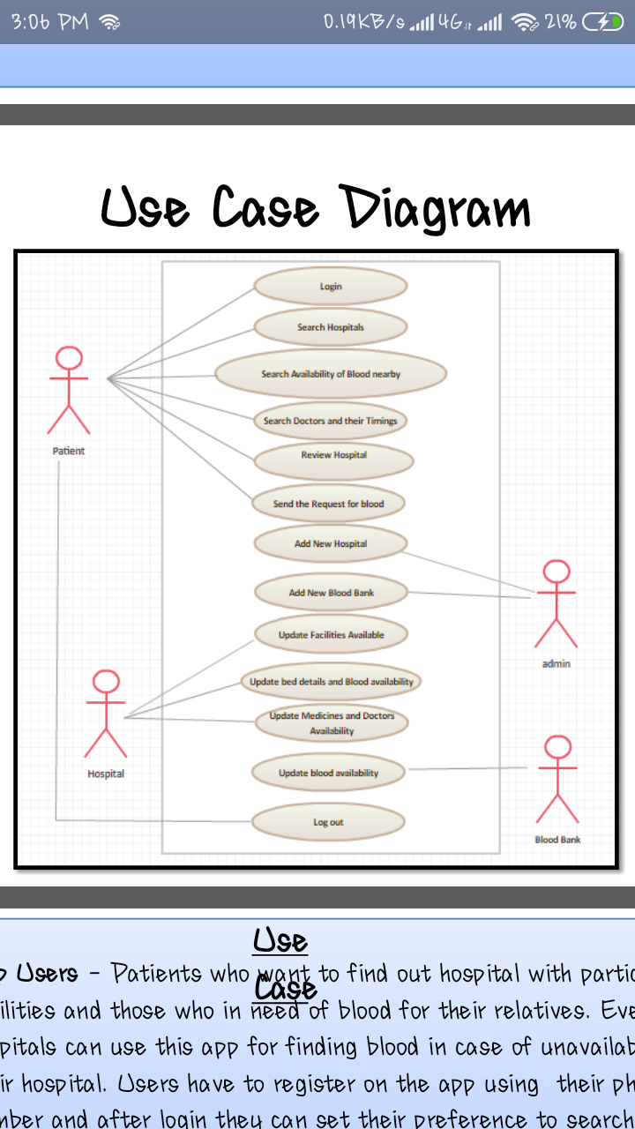

*Figure 5.4:UseCase Diagram*

The above use case diagram shows what system functions are performed for which actor. Roles of the actors in the system can be depicted.

**5.5 ER DIAGRAM**

In software engineering, an entity-relationship model (ERM) is an abstract and conceptual representation of data. Entity-relationship modeling is a database modeling method, used to produce a type of conceptual schema or semantic data model of a system, often a relational database, and its requirements in a top-down fashion. Diagrams created by this process are called entity-relationship diagrams, ER diagrams, or ERDs.



*Figure 5.5: ER Diagram*

**CHAPTER 6: METHODOLOGY**

At a finer level of detail, deploying the system consists of executing all steps necessary to educate the Consumers on the use of the new system, placing the newly developed system into  production, confirming that all data required at the start of operations is available and accurate, and validating that business functions that interact with the system are functioning properly. Transitioning the system support responsibilities involves changing from a system development to a system support and maintenance mode of operation, with ownership of the new system moving from the Project Team to the Performing Organization. [8] A key difference between system is that all project activities up to this point have been performed in safe, protected, and secure environments, where project issues that arise have little or no impact on day-to-day business operations. Once the system goes live, however, this is no longer the case. Any miscues at this point will almost certainly translate into direct operational and financial impacts on the performing Organization. It is through the careful planning, execution, and management of System Implementation activities that the Project team can minimize the likelihood of these occurrences, and determine appropriate contingency plans in the event of a problem.

**6.1 MODULES DESCRIPTION**



*Figure 6.1:Search Hospitals Module*

The above snapshot shows the Hospital Searching module of the application which is the core function of this Application development project. It has the options of filtering out the list of the various hospitals that are near to the location of the user. There can be number of such filters that may be applied on the search by the user while searching for the hospitals near to their location.

1. **Patient Age Group**



*Figure 6.2:Selecting Age group*

This is one of the important feature that needs to be taken into account as this could easily bring out better recommended results in the searching of the hospitals.

For instance, sometimes it may happen that a person needs to visit a paediatrician which is the doctor for infants and people of younger age. Then filtering that out, can help the person in terms of saving his time in going through different hospital lists.

1. **Symptoms: Disease and Department Prediction**



*Figure 6.3: Selecting Disease*

One of the unique features in this application is for the user to have an approximate prediction of the disease and what department the user needs to see. A list of immediate home remedies and test to confirm the disease is also suggested.

A person can thus choose the disease for which medication is needed and thus, the application can filter out the result list for him.

1. **Hospital Finder**



*Figure 6.4: Customising the Search*

In this, Android mobile application has been designed user friendly and user gets the information of particular hospital nearby to his location. This information shows in our mobile application screen with one by one and the patient can select the their best hospital.

1. **Getting Patient’s Location**

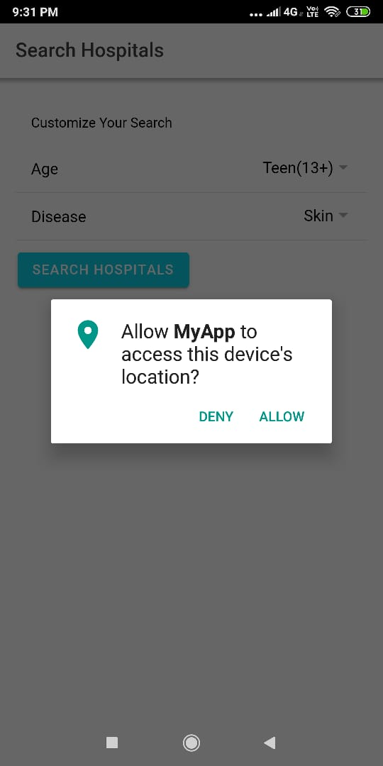

*Figure 6.5: Using GPS to Access location*

Usually, the existing systems require filtering the hospital list according to the cities that are given in a predefined list. But, this application differs from the existing systems in the way that it uses your location with the help of GPS. So, in a situation of hurry, the person does not needs to spend time selecting and filtering out the city or area of the location where hospital needs to be located.

**Others Modules:**

**Controlling Admin**

Every patient treated in hospital will be given unique Patient ID which is useful in tracking visits of patients. All patients’ data is useful for doctor’s purposes. Patient management system allows getting detail information of patient’s health condition.

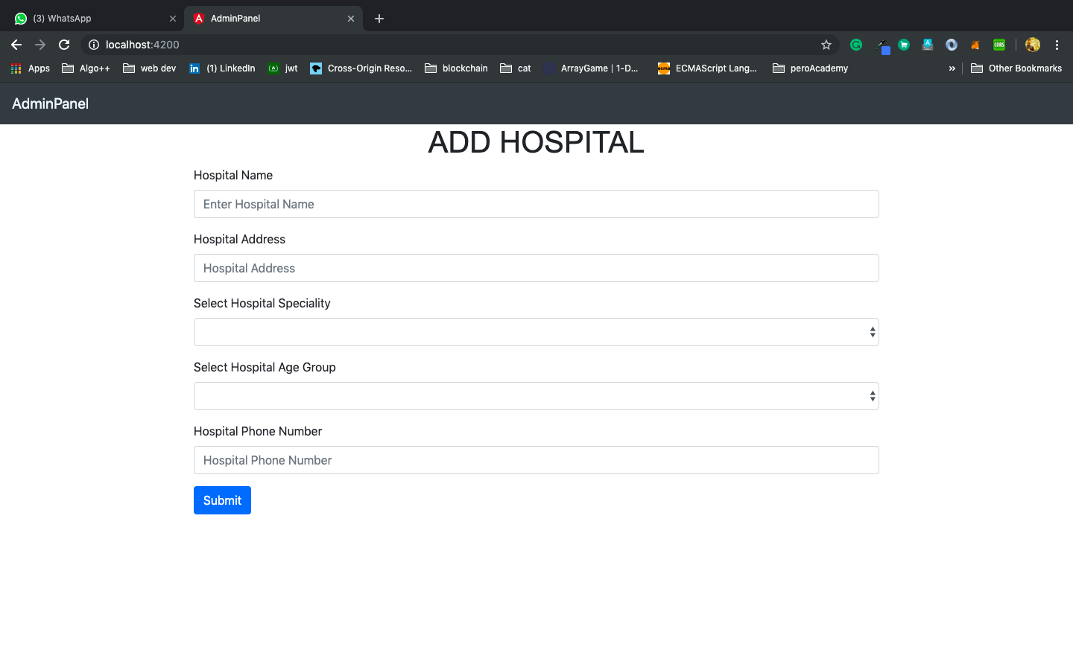

**BackEnd Hospital Database:**

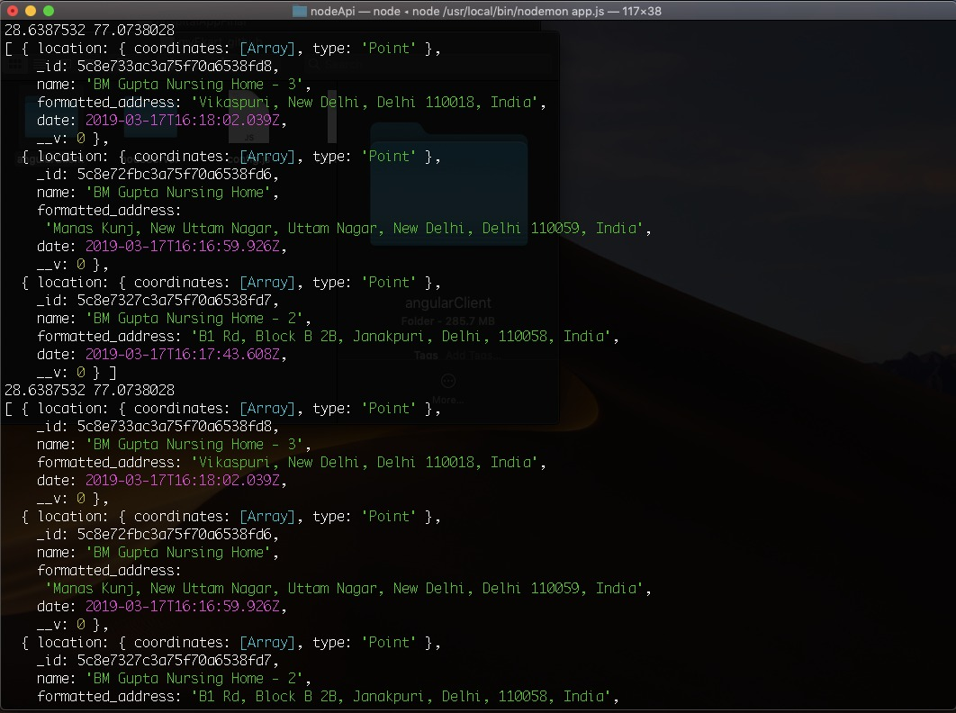

*Figure 6.6: Database in Mongo DB*

**CHAPTER 7: RESULTS AND DISCUSSION**

The proposed system gives a convenient and time saving solution for the existing system. It provides the facility to search all the nearby hospitals and doctor information in one place and also provides the time schedule for the availability of the doctors in that hospital, and also the application is so powerful that it can easily able to find your current location and then route you to the selected hospital without  putting any extra effort. Global Positioning System (GPS) enabled navigation in devices that precisely determines geographical location by receiving GPS co-ordinates information from the GPS satellites. Originally, it was only used by the United States military, but later this service is available freely worldwide and now most receivers are integrated into smartphones, PC tablets, airplanes, tracking devices and automobiles. At present, people feel more convenient to just use their Smartphone built-in GPS as navigation tools instead of a separate GPS device. Smartphone navigation typically gets free and speedy automatic updates as compare with commercial GPS devices.

By entering the various details and then searching out the hospitals of our location, we obtain the following output that displays a list of hospitals as per the departments selected by the user. Once the hospital is selected the address, phone number and route of the hospital is displayed.



*Figure 7.1: Hospital Information module*

**CHAPTER 8: CONCLUSION**

A healthcare application is developed which facilitates the patients a list of nearest hospitals and along with the feature of services availability. So this application provides the hospital details such as services types, specialization details etc.

The Android application is a full, open and free mobile device platform, with its powerful function and good user experience, rapidly developed into the most popular mobile operating system. A detailed introduction of Android application framework and the working principal of Android applications finally, a near place on the android platform was put forward to illustrate this mechanism. The project makes a basic and up-to-date medical category application and is designed to help the patients and caregivers to determine the nearest hospital with a specific specialization field. [7] The hospital names along with their address and route are determined by Smartphone GPS receiver within fifteen km of radius. With the help of Google Map, the distance and route to each of the hospital is displayed for the user. This application is greatly useful in emergency cases as well as for the non-resident person of the city.

**CHAPTER 9: FUTURE SCOPE**

There is always room for improvement in any field. By collecting surveys from its user the app can be revised according to the majorities need. A comparison and review feature of different hospitals and services by the user can be implemented. We can also create a forum to discuss patient’s experience which will give new users what to expect.

Further the scope of this application can be extended to develop and determine the availability of specialist doctor on a real-time basis near patient’s location. This development will also give an opportunity to book online appointment which facilitates the patients by saving the time  propose prototype implementation of home automation system that uses Wi-Fi technology and android OS. [4]

**REFERENCES**

[1] Muhammad Wasim Munir,Syed Muhammad Omair,M,Zeeshan UI Haque,” An Android  based Application for Determine a Specialized Hospital Nearest to Patient's Location, International Journal of Computer Applications(0975-8887) vol.11-no9,May 2015

[2] L. Atack L and J. Maher, “Emergency medical and health providers' perceptions of key issues in prehospital patient safety,” Prehosp Emerg Care, vol.14, no.1,pp.95-102,March 2010.

[3] M. Fourny, AS. Lucas, L. Belle, G. Debaty, P. Casez, H. Bouvaist, P. François, G. Vanzetto and J. Labarère, “Inappropriate dispatcher decision for emergency medical service users with acute myocardial infarction”, Am J Emerg Med., vol.29, no.1, pp.37-42, Jan. 2011.

[4] Akash Borate, KetanBhapkar, Darpan Sharma. "Android Based Fuzzy Inference System to Control the Fan Speed". Journal of Harmonized Research in Engineering 2(1), pg 69-74, 2014.

[5] Amit M. Farkade, Sneha R. Kaware. "The Android- A Widely Growing Mobile Operating System With its Mobile based Applications". International Journal of Computer Science and Mobile Applications", Vol.3 Issue. 1, pg. 39-45, January 2015.

[6] D.Saini, M. Mirza, mm. gori,CJ. Godwin, TB. Brown, MH. Battles and HF. Orthner, “Information needs of pre-hospital care  providers- a requirements analysis.”, AMIA annuSymp Proc. 2007, Chicago,IL,USA,Nov. 10-14 2007,pp.1098.

[7] Si Su, chon-Lian Shih, Weng-Chong Chen, Fu-Yuan Shi,Li-Hua Chen, Yu-Wen Wang, Establishing Simulation Models of EMS System, Final Report of Department of Health Project(DOH91-TD-1145),2003.

[8] KW. Neely, A. Bennison, J. Acker 3rd , D.  Long, RL. Norton, JA. Schriver, “Computerized hospital on-line resource allocation link (CHORAL): a mechanism to monitor and establish Policy for hospital ambulance diversions”, Prehosp Disaster Med, vol.6,no.4,pp.459-462,Dec 1991.

[9] B.Alan C, R. David E.C,S.M. Ts’aletseng, S. Ramabitsa,R. Mark B, “Application of the

analytical hierarchy process to establish health care waste management system that minimize infection risks in developing countries”,European Journal of operational Research vol.2007,no.181,pp.403-424, Oct. 2007.